ZONING SUMMARY TABLE

Zoning District | Minimum Lot Size |  |  |  | Lot Area |  |  | Impervious Surface |  | Height and Bulk
Zoning District | Lot of Record |  | New Lot |  | Front Yard, Min. | Side Yard, Min. | Rear Yard, Min. (ft.) | Total Lot Max. Area (%) | Front Yard Max. Area (%) | Building Height, Max. (ft.) | Floor Area Ratio, Max.
Zoning District | Area (s.f.) | Width (ft.) | Area (s.f.) | Width (ft.)
“R-1” | As Platted |  | 10,000 | 100 | Average of the planes of the two (2) existing main building façades of the two (2) lots, one of each located on either side of the lot being built. | 12% Lot Width, Not Less Than 10 ft. | 30 | 55 | 45 | 35 | 0.30
“R-2” |  |  | 10,000 | 85 |  | 12% Lot Width, Not Less Than 10 ft. | 30 | 55 | 45 | 35 | 0.30
“R-3” |  |  | 7,000 | 50 |  | 10% Lot Width, Not Less Than 6 ft. | 30 | 55 | 45 | 30 | 0.30
“R-4” |  |  | 6,500 | 50 |  | 10% Lot Width, Not Less Than 6 ft. | 30 | 55 | 45 | 35 | 0.30
“R-5” |  |  | n/a | n/a | n/a; Subject to Section 400.690 | n/a; Subject to Section 400.690 | n/a; Subject to Section 400.690 | n/a; Subject to Section 400.690 | n/a; Subject to Section 400.690 | 35 | n/a; Subject to Section 400.690
“C-1”¹ |  |  | 7,500 | 80 | 0 ft. min.  30 ft. max. | 10 ft. | 25 | 85 | 100 | 35 | n/a
“C-2”¹ |  |  | 10,000 | 100 | 0 ft. min.;  30 ft. max.;² | 0 ft.³;  10 ft.⁴ | 25 | 85 | 100 | 35 | n/a
“CVO” |  |  | Per Underlying Zoning; Minimum District Size of one (1) acre |  | 30 ft. min. | 12% Lot Width, Not Less Than 10 ft. | 30 | 65 | 30 | 35⁵ | n/a
“RCO” |  |  | Per Underlying Zoning; Minimum District Size of one-and-one-half (1.5) acres |  | 30 ft. min. | 12% Lot Width, Not Less Than 10 ft. | 30 | 45 | 30 | 35⁵ | n/a
- For “C-1” and “C-2” lots, a Front Yard Build-to Line is used.
- For “C-2” lots with a frontage on Sappington Road, Front Yard Build-to Line shall be a maximum of 35 feet.
- When abutting another “C-2” lot only; if a side yard is provided, it must be a minimum of 5 feet.
- When abutting an “R-1”, “R-2”, “R-3”, or “R-4” district.
- Except as provided for in Section 400.070.

CORNER LOTS

Where a lot is located at the intersection of two (2) or more streets, a Front Yard shall be provided on the street facing the front façade of the building, and a Front Yard shall be provided on the cross street, as outlined below. However, if front yard building lines are delineated on a subdivision plat of record, such lines may be the prevailing and required building lines.

Primary Front Yard: Average of the existing setbacks from the main building facades of the two closest lots on the same side of the street.

Cross Street Front Yard: Whichever is lesser of either:

A) 25 percent of the width of the primary front yard

B) Average of the existing setbacks from the main building facades of the two closest lots on the same side of the street.

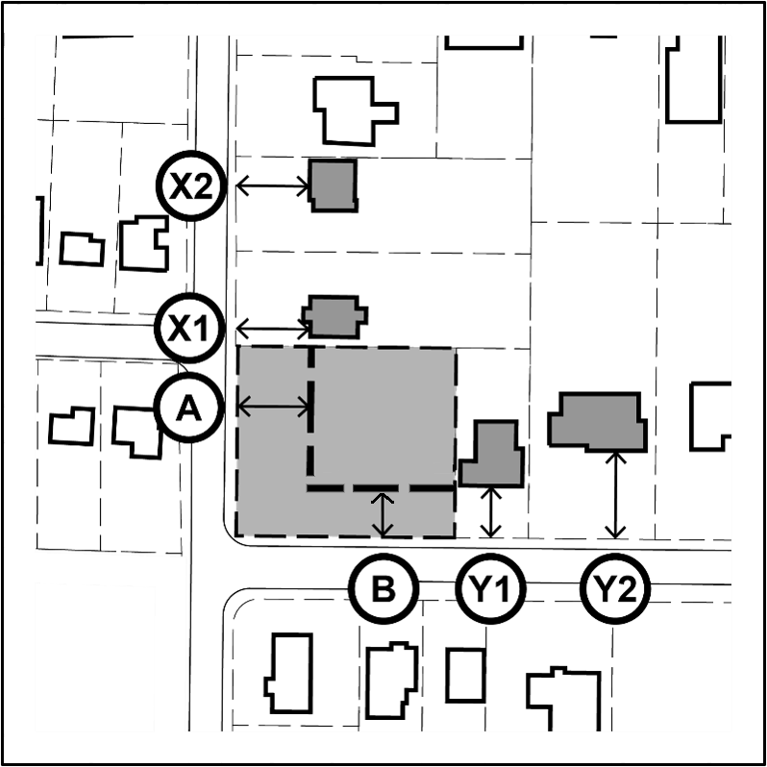

Figure 2: The corner lot subject property first Front Yard Setback Line (A) is the average of the neighboring building setbacks (X1) and (X2); the corner lot subject property cross street Front Yard Setback (B) is the lesser of 25% of the width of the front yard of the lot upon which the front façade of the building is located or the average of the neighboring building setbacks (Y1) and (Y2).
However, if front yard building lines are delineated on a subdivision plat of record, such lines may be the prevailing and required building lines.

FLOOR AREA RATIO (FAR)

The FAR limit for all lots zoned R-1, R-2, R-3 or R-4 is 0.30. FAR is calculated by dividing the gross floor area of a house by the total area of the lot.

- Gross Floor Area includes all areas provided with heat and/or air conditioning. Includes all conditioned half stories with ceiling heights of more than 5 feet.

- All living space with ceiling heights of sixteen (16) feet or greater shall be counted at 200%. Attached garages shall be counted at 50%.

- Any finished or unfinished basement, detached garages, and unenclosed porches are excluded.

ACCESSORY BUILDING AND STRUCTURES

The following rules for detached structures apply to all residential Single Family Zoning Districts.

Accessory Buildings (less than 12’ in height)
Includes detached garages, pools, sheds larger than 120 square feet, and any other fully enclosed building.

Front Yard: Not permitted in front yards
Side Yard: 6 feet
Rear Yard: 6 feet

Accessory Buildings (greater than 12’ in height)
The setbacks for accessory buildings greater than 12 feet in height are the same as for the main building on the lot. Accessory buildings may not exceed 20 feet in height, unless it is necessary to match the pitch of the accessory building’s roof to the pitch of the main residential structure’s roof and subject to the determination f the Building Commissioner.

Lot Coverage
Accessory buildings which are not a part of the main building shall not occupy more than thirty percent (30%) of the rear yard. Accessory buildings shall not be closer than ten feet to the main building or to another accessory building.

Accessory Structures
Includes sport courts, gazebos, pergolas, and sheds less than 120 square feet. May not exceed 20 feet in height.

Front Yard: Not permitted in front yards
Side Yard*: 6 feet
Rear Yard*: 6 feet

Sheds that are less than 120 square feet may be built no nearer than 2 feet to the side or rear lot line.

